|  |  |
| --- | --- |
| CONTENTS | Page No. |
| 1.Abstract |  |
| 2.Acknowledgement |  |
| 3.Certificate from Company |  |
| 4.Student declaration |  |
| 5.Introduction |  |
| 6.Company profile |  |
| 7.Scope of the system |  |
| 7.1 Existing system |  |
| 7.2 Problem statement |  |
| 7.3 Proposed system |  |
| 8.System analysis |  |
| 8.1 Review of literature |  |
| 8.2 Review of research |  |
| 8.3 Feasibility study |  |
| 8.4 Tools Technology |  |
| 8.5 Hardware and Software requirements |  |
| 9. Planning |  |
| 9.1 Overall description |  |
| 9.1.1 Product perspective |  |
| 9.1.2 Product functions |  |
| 9.2 User modules |  |
| 9.3 Functional and Non-functional requirements |  |
| 10. System Design |  |
| 10.1 System perspective |  |
| 10.2 DFD diagrams |  |
| 10.3 UML diagram. |  |
| 10.4 Database diagram |  |
| 11. Screen shots |  |
| 12.Software testing |  |
| 12.1 Test cases |  |
| 12.1.1 Test case for Employee |  |
| 12.1.2 Test case for Admin |  |
| 13.Conclusion |  |
| 14.Limitations |  |
| 15.Future enhancement |  |
| 16.Reference |  |
| 17.Appendix |  |
| 17.1 User manual |  |
| 18. Bibliography |  |

1. **ABSTRACT**

The **Web-Based Learning Management Solution** (LMS) is a practical and scalable platform designed to make teaching, training, and knowledge-sharing efficient, interactive, and personalized. From content creation and course delivery to learner **progress tracking and automated reminders**, the system ensures that learning activities are seamlessly managed and monitored. In today’s fast-evolving digital environment, having a reliable LMS is essential for organizations and institutions to streamline training, improve learner engagement, and enhance knowledge retention.

Traditional training methods, often dependent on scattered documents and manual tracking, frequently result in inefficiencies, missed deadlines, and difficulties in assessing performance. This solution addresses those challenges by providing a centralized platform with **role-based access**, **dynamic dashboards, real-time progress reporting, and AI-powered quiz generation** for better learning outcomes.

Built using the **MERN stack (MongoDB, Express.js, React.js, and Node.js)**, the LMS combines responsive front-end design with robust back-end processing and a scalable database structure. Key features such as **admin-controlled content management, personalized learner dashboards, automated email reminders, and Gemini API–powered quiz generation** not only improve usability but also increase accountability and ensure effective monitoring of learner progress.

1. **ACKNOWLEDGEMENT**
2. **CERTIFICAT FROM COMPANY**
3. **STUDENT DECLARATION**
4. **INTRODUCTION**
5. **COMPANY PROFILE**
6. **SCOPE OF THE SYSTEM**

The scope of the LMS covers the needs of **administrators, learners, and organizations** by offering a **flexible, scalable, and user-friendly platform** for digital learning:

* **For Administrators:**
  + Manage users, courses, and content efficiently.
  + Generate quizzes automatically using the **Gemini API**.
  + Access reporting dashboards for real-time progress and performance.
  + Send **automated and manual email reminders** to learners.
* **For Learners:**
  + Access a **personalized dashboard** with assigned courses.
  + View progress, deadlines, and completion status.
  + Explore a course catalog with **search and filter functionality**.
  + Attempt quizzes and track scores instantly.
* **For Organizations:**
  + Streamline the **training and knowledge-sharing process**.
  + Improve **accountability and decision-making** with accurate reports.
  + Reduce reliance on manual tracking, saving **time and administrative effort**.
  + Enhance **learning effectiveness and compliance monitoring**.
  1. **Existing system**

Currently, learning and training management in many organizations is handled through **manual methods**, such as shared documents, email communications, and basic record-keeping tools. While these methods provide a simple way to share content, they often cause **inconsistencies, delays, and poor learner engagement**. Learners struggle to track their progress, and administrators face challenges in monitoring completion, sending reminders, and generating accurate reports. As the number of learners and courses grows, these limitations result in **inefficient training delivery, reduced accountability, and poor decision-making**.

* 1. **Problem statement**

The absence of a centralized and automated system for learning management creates major operational challenges. Manual tracking of courses and learners increases the risk of missed deadlines, incomplete progress data, and low participation rates. Administrators spend significant time preparing reports and sending reminders, while learners often lack clarity about their assigned courses and progress. This leads to wasted time, lower training effectiveness, and difficulties in performance evaluation, especially when quick and accurate data is required for compliance and decision-making.

* 1. **Proposed system**

The proposed **Web-Based Learning Management Solution (LMS)** provides a **centralized, automated platform** for managing the complete learning lifecycle, from **content creation and course delivery to progress tracking and reporting**. It enables administrators to **upload and manage content**, create structured courses, and generate quizzes using the **Gemini API**. Learners get **personalized dashboards** showing mandatory and optional courses, deadlines, and progress status. Additional features like **real-time reporting, automated email reminders, and role-based access** make the system reliable and efficient. This solution overcomes the limitations of manual methods, reduces administrative effort, and improves overall **training effectiveness and accountability**.

1. **SYSTEM ANALYSIS**

System analysis is an essential step in developing the **Web-Based Learning Management Solution (LMS)**. It evaluates the current learning management practices, identifies existing gaps, and defines the requirements for creating a centralized, automated, and scalable platform. This stage ensures that the proposed solution is **technically feasible, cost-effective, and aligned with organizational training needs**.

* 1. **REVIEW OF LITERATURE**

Learning Management Systems (LMS) and e-learning platforms have been widely studied in the fields of **education technology and organizational training**. Research highlights that traditional learning methods relying on **manual tracking, shared files, or email-based communication** often result in **inconsistent progress tracking, low engagement, and poor accountability**.

Key findings from literature emphasize:

* **Centralized learning platforms** to improve accessibility and monitoring.
* **Role-based dashboards** to cater to admins, instructors, and learners.
* **Automated reporting and notifications** to enhance learner participation.
* **AI-powered assessments** for dynamic and scalable evaluation.

Studies consistently support **web-based solutions** with **user-friendly interfaces, scalable databases, and automation features**, which directly improve learning effectiveness and organizational training outcomes.

* 1. **REVIEW OF RESEARCH**

Recent research in e-learning systems and enterprise training shows that adopting **cloud-enabled and web-based LMS platforms** results in:

* **Higher learner engagement** through personalized dashboards.
* **Improved compliance and reporting** with real-time analytics.
* **Reduced administrative workload** via automated reminders and progress tracking.
* **Smarter assessments** with AI-based quiz generation.

Modern technology stacks, such as the **MERN stack (MongoDB, Express.js, React.js, Node.js)**, are proven to enhance **system scalability, responsiveness, and user experience**. These findings validate the **technological choices** made for this LMS project.

* 1. **FEASIBILITY STUDY**

|  |  |
| --- | --- |
| **Type of Feasibility** | **Key Findings** |
| **Technical** | The project uses the **MERN stack** (MongoDB, Express.js, React.js, Node.js), ensuring compatibility with existing IT infrastructure and supporting scalability. |
| **Operational** | A **user-friendly interface** with role-based dashboards and automated workflows ensures smooth adoption with minimal training. |
| **Economic** | The development cost is lower than the long-term expenses of manual training and tracking, making the system **cost-effective**. |

* 1. **TOOLS TECHNOLOGY**

The LMS uses a **modern web-based technology stack** to ensure performance, scalability, and maintainability.

* **Frontend:** ReactJS with Tailwind CSS for a **responsive and interactive user interface**.
* **Backend:** Express.js and Node.js to handle **business logic and APIs**.
* **Database:** MongoDB for **scalable and flexible data storage**.
* **AI Integration:** Gemini API for **automated quiz generation**.
* **Other Tools:**
  + Axios for API communication.
  + Nodemailer/SendGrid for automated email reminders.
  + Git/GitHub for version control and collaboration.
  + Docker (optional) for containerized deployment.
  1. **HARDWARE AND SOFTWARE REQUIREMENTS**

**Hardware:**

|  |  |
| --- | --- |
| **Component** | **Specification** |
| **Server** | Quad-core processor, 8 GB RAM, 250 GB SSD storage |
| **Client Systems** | Dual-core processor, 4 GB RAM, modern web browser |
| **Network** | Stable internet connection (LAN/Wi-Fi) |

**Software:**

|  |  |
| --- | --- |
| **Category** | **Specification** |
| **Operating System** | Windows / Linux / macOS |
| **Frontend** | ReactJS, Tailwind CSS |
| **Backend** | Node.js , Express.js |
| **Database** | MongoDB |
| **AI Integration** | Gemini AI |
| **Tools** | Git, VS Code, Docker (optional), Nodemailer |

1. **PLANNING**

Planning is a crucial stage in developing the **Web-Based Learning Management Solution (LMS)**. It sets the main objectives, defines system functions, and outlines how the product will work in real-world situations. The purpose is to ensure that every feature, from **course creation** to **progress tracking and reporting**, is clearly understood before implementation.

* 1. **OVERALL DESCRIPTION**

The **Learning Management Solution (LMS)** is a **centralized, web-based application** designed to simplify the complete lifecycle of digital learning. It provides organizations with a single platform to **create, deliver, and monitor courses**, while also tracking learner progress and assessments. This ensures **real-time updates, structured learning paths, and improved accountability**.

The system removes the inefficiencies of manual training and email-based communication by offering **automated workflows, user-specific dashboards, and detailed reporting**. This reduces administrative workload, enhances learner engagement, and supports **better decision-making** for organizational training programs.

* + 1. **PRODUCT PERSPECTIVE**

The proposed LMS acts as an **independent web application** that integrates smoothly with an organization’s existing IT setup. It follows a **client-server model**:

* **Frontend:** A responsive **ReactJS interface** with Tailwind CSS for learners and administrators, accessible via desktops, laptops, or mobile devices.
* **Backend:** **Node.js and Express.js** for API handling, quiz generation workflows, and business logic.
* **Database:** **MongoDB** for scalable and flexible data management.
* **AI Integration:** **Gemini API** for automated quiz generation from course content.

The product is **scalable**, supporting the addition of new courses, user roles, and groups as the organization grows. It runs on standard web browsers, requiring no special hardware on the client side.

* + 1. **PRODUCT FUNCTIONS**

The LMS provides the following key functions:

* **Content Management:** Admins can upload documents, videos, and presentations, and create structured courses with a rich-text editor.
* **Personalized Dashboards:** Learners get a customized dashboard with assigned courses, deadlines, and progress indicators.
* **Course Catalog & Search:** Users can browse and filter available courses by category, difficulty, or deadline.
* **AI-Powered Quiz Generation:** Admins can upload Word documents to automatically generate multiple-choice quizzes using the Gemini API.
* **Progress Tracking:** Real-time monitoring of course completion, quiz results, and learner performance.
* **Automated Email Reminders:** Notifications for upcoming deadlines or incomplete courses.
* **Reports & Analytics:** Detailed dashboards for admins to evaluate learner progress and training effectiveness.
  1. **USER MODULES**

The LMS is designed with **role-based modules** to ensure controlled access and clear responsibilities:

|  |  |
| --- | --- |
| **User Type** | **Key Responsibilities** |
| **Admin** | Manage users, upload content, create courses, generate quizzes, track learner progress, send reminders, and generate reports. |
| **Manager/Supervisor** | Monitor learner performance within teams, review reports, and ensure compliance with deadlines. |
| **Employee/User** | Access assigned courses, track progress, complete quizzes, and explore optional learning material |

* 1. **FUNCTIONAL AND NON-FUNCTIONAL REQUIREMENTS**

**Functional Requirements**

The system must:

* Allow admins to **add, edit, and delete courses and learning content**.
* Provide **user authentication with role-based access control**.
* Enable learners to view their **personalized dashboard** with course details, deadlines, and progress.
* Automatically generate **quizzes from uploaded documents** using the Gemini API.
* Send **email notifications and reminders** for deadlines and incomplete courses.
* Track **user progress, quiz scores, and completion status**.
* Generate **real-time reports and analytics** for admins.

**Non-Functional Requirements**

The system should:

* **Performance:** Handle multiple users accessing courses and quizzes simultaneously with low response time.
* **Scalability:** Support a growing number of users, courses, and content without major redesign.
* **Security:** Protect sensitive user and course data with encryption and role-based authentication.
* **Reliability:** Ensure consistent uptime with automatic backups for user and course data.
* **Usability:** Provide an intuitive, easy-to-use interface for both learners and admins.
* **Compatibility:** Run smoothly on major web browsers (Chrome, Firefox, Edge, Safari) and operating systems (Windows, Linux, macOS).

**10. SYSTEM DESIGN**

The System Design phase translates the functional requirements into a concrete technical blueprint for the **Web-Based Learning Management Solution (LMS)**. This phase defines the overall architecture, data flows, component interactions, and database structure to ensure the system is **scalable, secure, maintainable, and performant**.

**10.1 SYSTEMS PERSPECTIVE**

The LMS is designed as a multi-tier, web-based application following a client–server architecture with an optional AI integration layer for quiz generation:

**Client Layer (Frontend):**

* Built with **ReactJS** and Tailwind CSS for a responsive, accessible UI.
* Provides role-based views: **Admin**, **Instructor (optional)**, **Learner**, and **Manager**.
* Handles authentication flows, dashboard rendering, course playback, quiz interfaces, and file uploads (documents/videos).
* Communicates with backend over secure HTTPS REST/GraphQL APIs using Axios or fetch.

**Application Layer (Backend):**

* Implemented with **Node.js + Express.js** (or similar).
* Exposes RESTful (or GraphQL) APIs for user management, course/content management, quizzes, progress tracking, reporting, and notifications.
* Implements business logic: course lifecycle, quiz generation workflow, role-based authorization, progress calculations, scheduler for reminders, and email integration (SendGrid/Nodemailer).
* Contains an **AI Integration Module** that: accepts uploaded Word documents, sends content to the **Gemini API**, parses responses, and creates quiz questions/answers.
* Includes background workers (e.g., using Bull / Node cron / serverless functions) for heavy tasks: document parsing, quiz generation, email reminders, and report generation.

**Data Layer (Database & Storage):**

* **Primary DB:** **MongoDB** for flexible, document-oriented storage of users, courses, chapters, progress, and quizzes.
* **File Storage:** Cloud object storage (S3 / compatible) for videos, large documents, and attachments.
* **Search/Indexing (optional):** ElasticSearch / MongoDB Atlas Search for course catalog search and filters.
* **Caching (optional):** Redis for session caching, rate-limiting, and background-job locking.

**Security & Infra Considerations:**

* HTTPS/TLS, JWT/OAuth for authentication tokens, role-based access control (RBAC), input validation, rate limiting, and secure file handling.
* Containerized deployment (Docker) and CI/CD pipeline for automated testing and deployment (Vercel/Heroku/GCP/AWS).

This architecture supports real-time updates, automated tasks, and secure integration with AI services while remaining horizontally scalable.

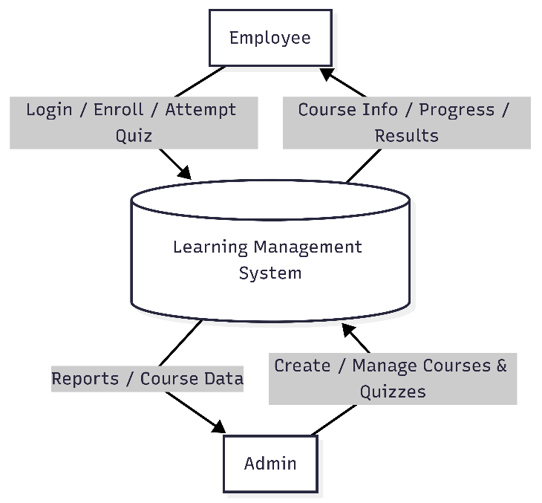**10.2 DFD DIAGRAMS**

**Fig 1. DFD Level 0**

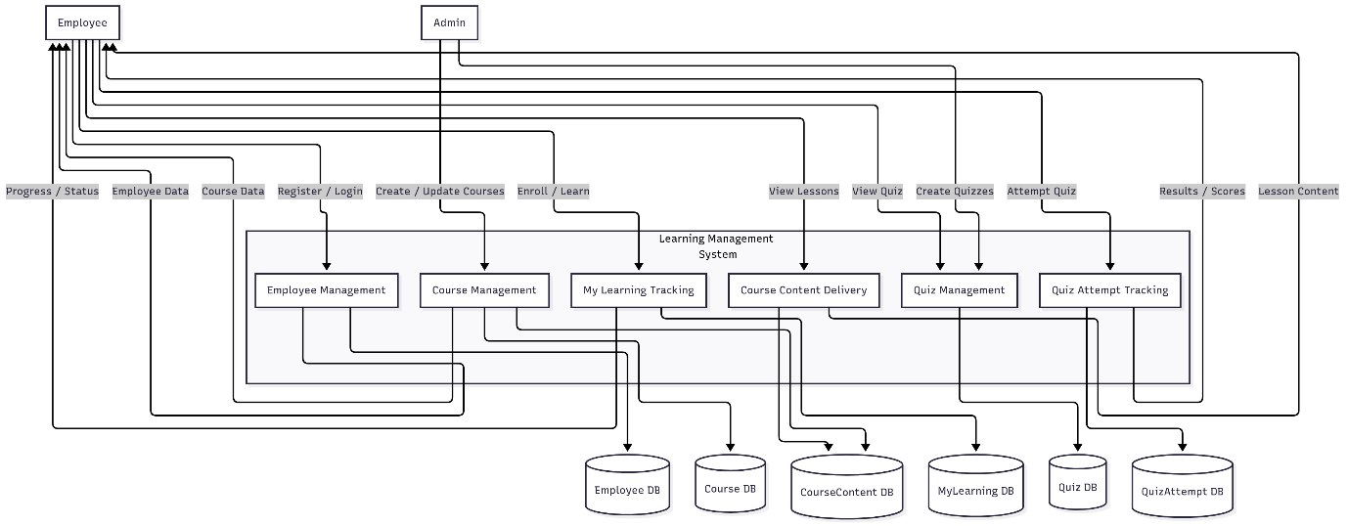

**Fig 2 . DFD Level 1**

**Fig 3. DFD Level 2**

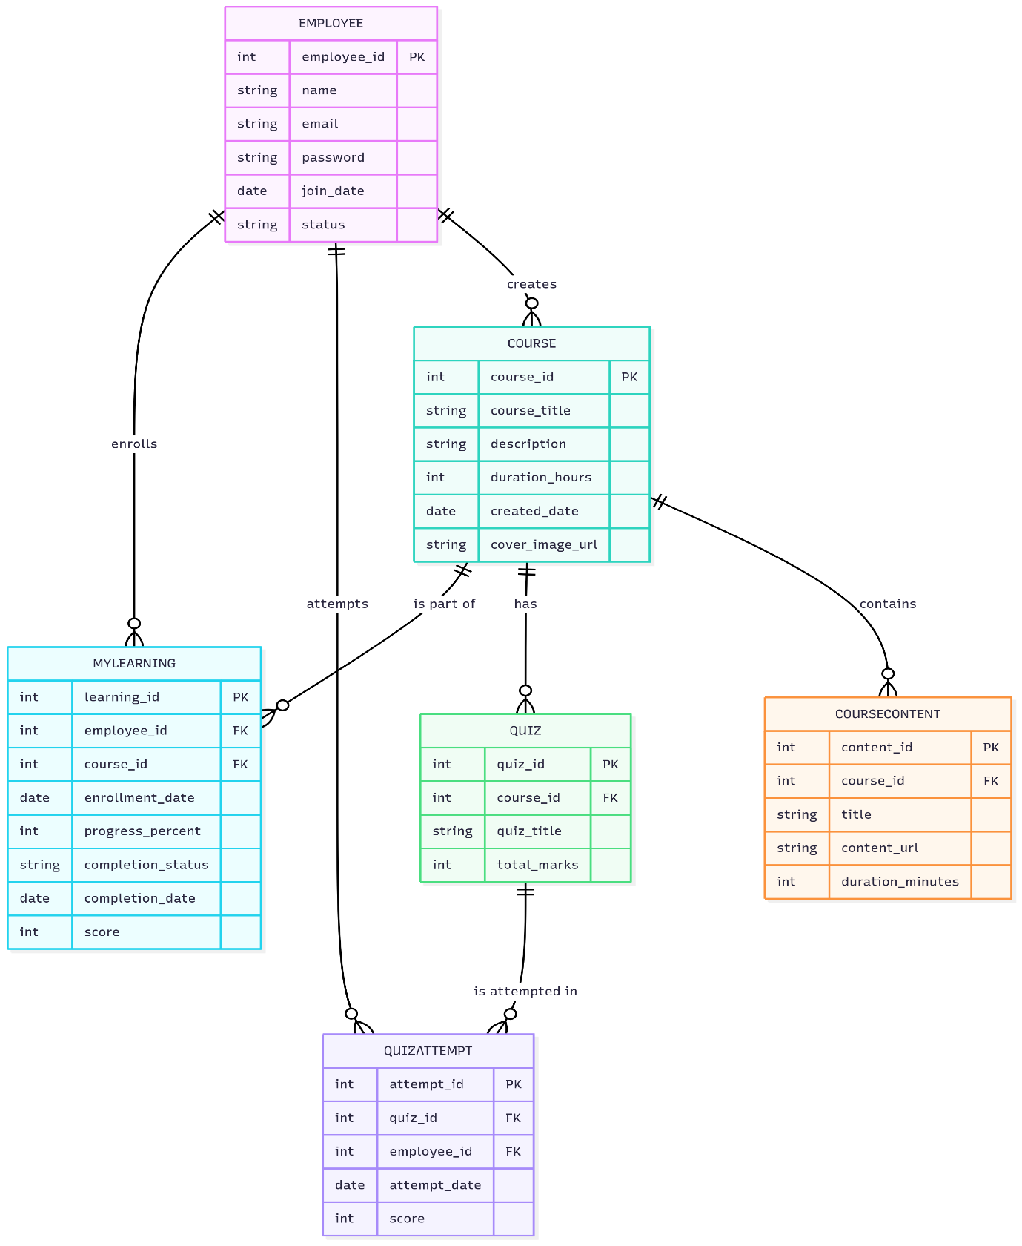

**Fig 4. ER Diagram**

**10.3 UML DIAGRAM**

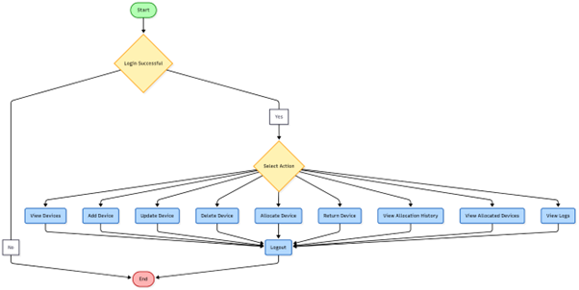**Fig 1. Class Diagram**

**Fig 1. Activity Diagram**

**Fig 1. Sequence Diagram**

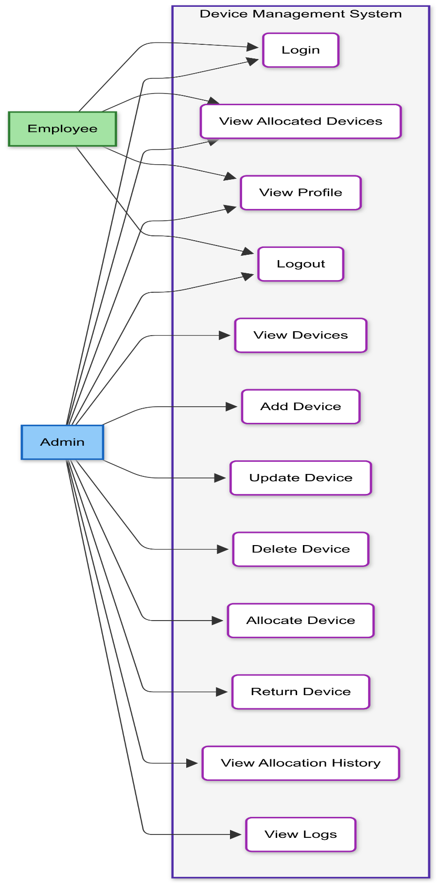

**Fig 1. Usecase Diagram**

**10.4 DATABASE DIAGRAM**

**Fig 1. Database Diagram**

**11. SCREEN SHOTS**

**Employee access**

Fig. 1: Employee Dashboard

This dashboard displays the user’s name and ID, and lists all assigned devices (monitor, keyboard & mouse, headset, laptop and Dock) with their make, model, serial number, and deployed status. The page is read-only for tracking assets—no editing or deleting is allowed.

Fig. 2: Employee Profile

This profile page displays the employees name, email, employee number, designation, department, supervisor, manager, and date of joining.

**User/Admin access**

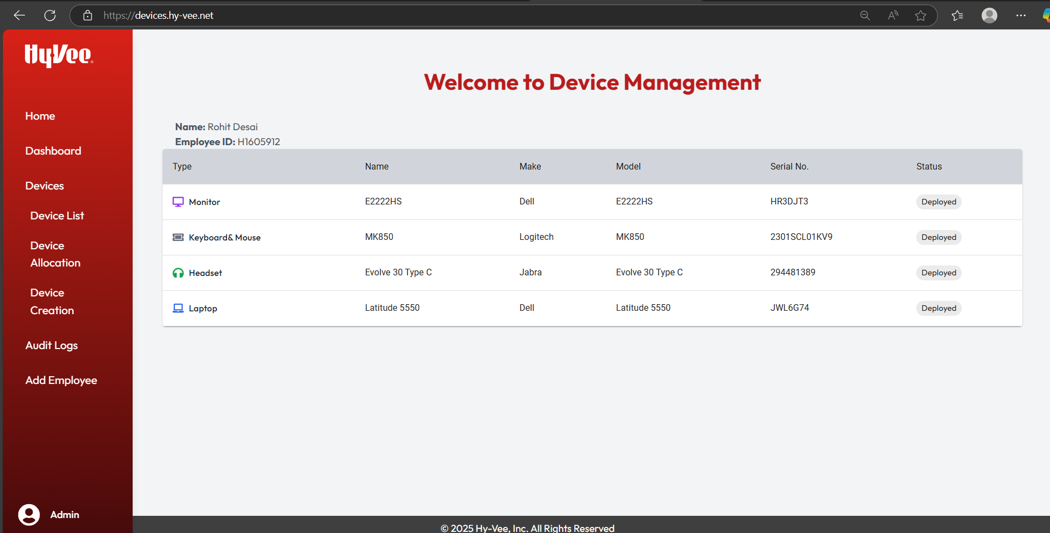

Fig. 3: Admin Dashboard

This dashboard shows the user’s name, ID, and assigned devices with full details in a read-only view. Unlike the employee view, the sidebar here has extra options like Dashboard, Device List, Device Allocation, Device Creation, Audit Logs, and Add Employee giving the user more privileges and admin access.

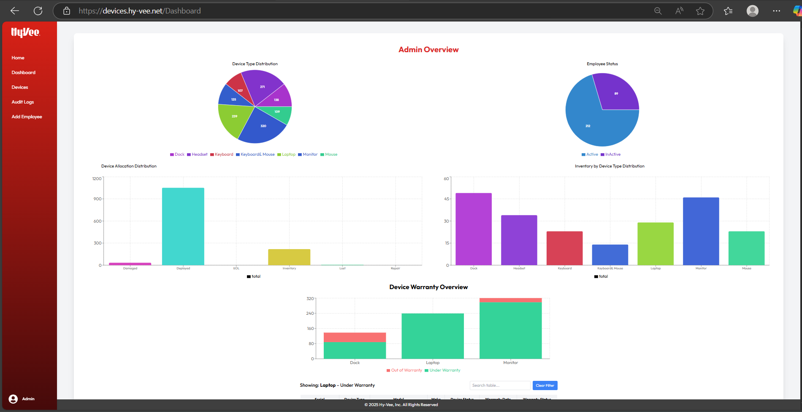

Fig. 4: Admin Analytics Dashboard

This dashboard provides an admin overview using various charts and graphs. It displays device type distribution, employee status, device allocation, inventory by device type, and device warranty, offering admins a clear snapshot of asset usage, employee allocation, and warranty status across the organization.

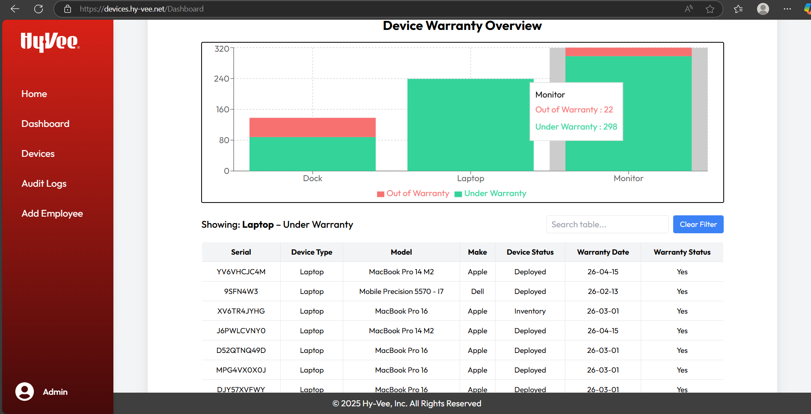

Fig. 5: admin analytics dashboard

This section displays a bar chart for device warranty status showing which devices are "under warranty" (green) or "out of warranty" (red). When you click on either the green or red section of a bar, the table below updates to show detailed information for that category. For example, clicking the green bar for laptops will list all laptops currently under warranty with.

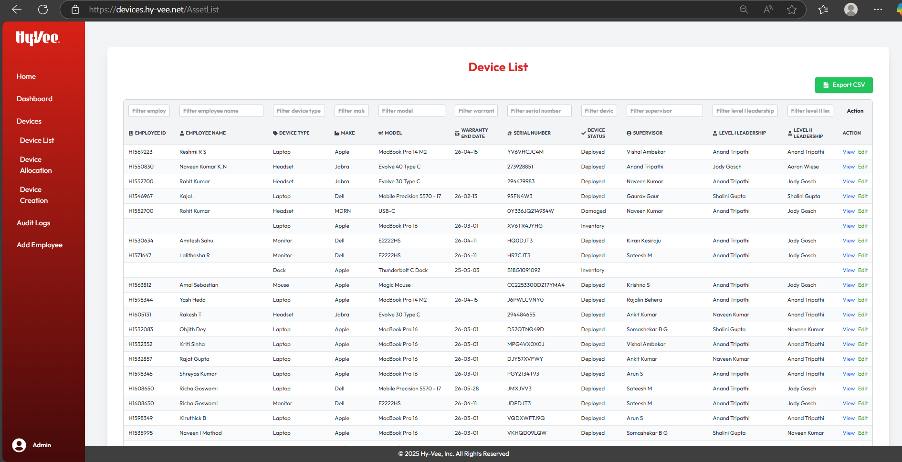

Fig. 5: Device List

This page shows a comprehensive list of all devices in the organization, including device details and leadership hierarchy. Users can filter devices by various parameters and export the data to CSV. “View” and “Edit” options allow admins to see or modify device details as needed.

Fig. 6: Device View

This page shows detailed information about a specific asset, including employee details, asset specifications, purchase and warranty info, device allocation history, and related Jira history.

Fig. 7: Device Edit

This page lets admins edit device details. After submission, updates are reflected in the system and visible in the Device List and Device View.

Fig. 8: Device Allocation Form

This page allows admins to allocate devices by selecting an employee, device type, device from inventory, device status, and entering a Jira ID and remarks. Once the Jira ID is validated, the submit button is enabled, and upon submission, the device is assigned to the selected employee.

Fig. 9: Device Creation

This page allows admins to add new devices by entering details. Devices can also be added in bulk using the CSV upload feature at the top.

Fig. 10: Audit Log Form

This page lets admins search and filter audit logs by employee, device, and date. The results table displays detailed audit records of device activity such as status changes and the admin involved helping track historical actions.

Fig. 11: Employee Form

In case of any glitches or issues with Workday employee additions, this page provides an alternative way for admins to add employees directly. It allows entering details. Upon submission, the new employee is registered in the system.

**12. Software testing**

Software testing is an essential step in ensuring the **Web-Based Learning Management Solution (LMS)** performs correctly, securely, and efficiently.  
It validates that each feature — from course creation and content upload to employee enrollment, quiz generation, and progress reporting — functions as intended under different scenarios.

Testing confirms that the system meets both **functional and non-functional requirements**, detects errors early, and ensures that Admin and Employee interactions across the LMS are seamless and reliable.

**12.1 Objective of testing**

Test main objectives of testing for this LMS are to:

* Detect and fix software bugs before deployment.
* Ensure that Admin and Employee modules function independently and integrate correctly.
* Validate the accuracy of data flow between front-end and back-end.
* Confirm that external services (Gemini API, email reminders) work as expected.
* Test system security, usability, and responsiveness across different devices and roles.

**12.2 Testing Levels**

* **Unit Testing** – Verified each function and component such as login, course creation, enrollment, and quiz generation individually.
* **Integration Testing** – Ensured that modules like Course Management, Enrollment, and Reporting work cohesively.
* **System Testing** – Tested complete workflows from Admin content creation to Employee progress completion.
* **User Acceptance Testing (UAT)** – Conducted with actual users to ensure the application meets business and user expectations.

**12.3 Test cases**

Test cases define the specific inputs, execution conditions, and expected outcomes for each functionality.

The following tables present representative test cases for **Admin** and **Employee** modules.

|  |  |  |  |
| --- | --- | --- | --- |
| **Test Case ID** | **Test Scenario** | **Expected Result** | **Status** |
| EMP-01 | Employee Login Validation | Employee successfully logs in and is redirected to personalized Dashboard. | Pass/Fail |
| EMP-02 | View Assigned Courses | Dashboard shows all mandatory and optional courses with status indicators. | Pass/Fail |
| EMP-03 | Enroll in Optional Course | Employee successfully enrolls in optional courses and progress is updated. | Pass/Fail |
| EMP-04 | View Course Details | Course image, title, description, and duration load correctly from database. | Pass/Fail |
| EMP-05 | Access Learning Material | Employee can view uploaded documents, watch videos, and read chapters. | Pass/Fail |
| EMP-06 | Attempt Quiz | Employee can attempt quizzes generated from Gemini API and submit responses. | Pass/Fail |
| EMP-07 | Track Progress | Progress bar updates accurately after completing chapters or quizzes. | Pass/Fail |
| EMP-08 | Receive Deadline Reminder | Employee receives email reminders before course deadlines. | Pass/Fail |

**12.3.1 Test case for Employee**

**12.3.2 Test case for Admin**

|  |  |  |  |
| --- | --- | --- | --- |
| **Test Case ID** | **Test Scenario** | **Expected Result** | **Status** |
| ADM-01 | Admin Login Validation | Admin is successfully logged in and redirected to the Admin Dashboard. | Pass/Fail |
| ADM-02 | Create New Course | A new course record is successfully created and stored in the database. | Pass/Fail |
| ADM-03 | Upload Course Materials | Uploaded videos, documents, and presentations are stored and accessible to employees. | Pass/Fail |
| ADM-04 | Gemini API Quiz Generation | Multiple-choice quiz is automatically generated from uploaded Word document. | Pass/Fail |
| ADM-05 | Assign Course to Employees | Selected employees receive assigned course notifications and deadlines. | Pass/Fail |
| ADM-06 | Send Email Reminders | Reminder emails are sent to employees before or after deadlines. | Pass/Fail |
| ADM-07 | View Reports & Progress | Dashboard displays completion status, quiz scores, and course progress for all users. | Pass/Fail |
| ADM-08 | Manage Employee Accounts | Admin can add, edit, or deactivate employee accounts successfully. | Pass/Fail |

**13. CONCLUSION**

The **Web-Based Learning Management Solution (LMS)** provides an efficient, modern, and scalable platform for managing learning and training activities within an organization. By integrating both **Admin** and **Employee** functionalities into a single application, the system streamlines processes such as course creation, enrollment, progress tracking, and performance reporting.

Built using the **MERN stack (MongoDB, Express.js, React, Node.js)**, the solution ensures a fast, secure, and responsive user experience capable of handling multiple users and real-time updates. The integration of the **Gemini API** for automatic quiz generation demonstrates the project’s adaptability and innovation, reducing manual work and enhancing assessment efficiency.

The LMS’s intuitive interface, structured data flow, and automated reminders minimize administrative overhead, improve learner engagement, and ensure timely course completion. Overall, this project highlights how modern web technologies can transform organizational learning management into a seamless, data-driven process, offering a strong foundation for future enhancements such as analytics dashboards, mobile access, and AI-driven personalization.

**14. LIMITATIONS**

While the Web-Based Learning Management Solution effectively handles online learning and course management within an organization, it has a few limitations. The current system requires a constant and stable internet connection, which limits accessibility in areas with weak or intermittent connectivity. The database and application design are well-suited for small to medium-sized organizations, but larger enterprises with thousands of users may require additional scalability measures such as cloud-based load balancing or distributed databases.

At present, communication features are limited to email notifications for course reminders and progress updates. Other options, such as SMS alerts, push notifications, or real-time in-app messaging, are not yet implemented. The platform is also designed for single-organization use, meaning it does not support multi-tenant functionality where multiple institutions or departments could use the same system while maintaining separate data sets.

These limitations do not hinder the normal operation of the system but highlight potential areas for future enhancement — such as offline accessibility, advanced scalability, and richer communication capabilities — to make the LMS more versatile and enterprise-ready.

**15. FUTURE ENHANCEMENT**

The **Web-Based Learning Management Solution (LMS)** is designed with scalability and adaptability in mind. It can continue to evolve to meet the dynamic needs of organizations and learners. Several improvements can be introduced in future versions to enhance its overall functionality, performance, and user experience.

**1. AI-Powered Personalized Learning**

Integrating artificial intelligence (AI) will allow the LMS to provide personalized course recommendations based on each user’s learning history, performance, and interests. The system could analyze progress patterns and suggest relevant modules, helping employees focus on their skill gaps. AI-driven learning paths would increase engagement, ensure targeted learning outcomes, and make the platform more adaptive to individual learning styles.

**2. Mobile Application Development**

Developing a dedicated mobile application for the LMS would make learning accessible anytime and anywhere, even with limited connectivity. Offline access to downloaded course materials and quizzes could ensure uninterrupted learning. A mobile app with real-time notifications, progress tracking, and push reminders would improve engagement and flexibility for employees who prefer on-the-go learning.

**3. Multi-Tenant Support for Enterprises**

Enhancing the LMS to support **multi-tenant architecture** would enable multiple organizations or departments to use the same system independently. Each tenant could manage their users, courses, and reports without data overlap. This feature would make the solution more scalable and suitable for training divisions across large enterprises or educational institutions.

**5. Advanced Analytics and Reporting Dashboard**

An upgraded analytics dashboard can provide admins with deeper insights into learner engagement, completion trends, quiz performance, and course effectiveness. Visual data charts and predictive analytics could help identify employees at risk of missing deadlines and improve decision-making for content strategy and employee development plans.

**16. REFERENCE**

**Technical Documentation & Framework References**

* **Axios (HTTP Client)** – https://axios-http.com/docs/intro
* **MongoDB Documentation** – <https://www.mongodb.com/docs>
* **Express.js Documentation** – https://expressjs.com/en/guide/routing.html
* **React Official Documentation** – https://react.dev/
* **Node.js Documentation** – https://nodejs.org/en/docs
* **Mongoose (MongoDB ODM)** – https://mongoosejs.com/docs/guide.html
* **JSON Web Tokens (JWT)** – <https://jwt.io/introduction>
* **RESTful API Design Guidelines** – <https://restfulapi.net>
* **HTML5 Official Specification** – <https://developer.mozilla.org/en-US/docs/Web/Guide/HTML/HTML5>
* **TailwindCSS Styling** – <https://tailwindcss.com/plus/ui-blocks/documentation>
* **JavaScript Guide** – <https://developer.mozilla.org/en-US/docs/Web/JavaScript/Guide>

**Project Development & Tools**

* Visual Studio Code – https://code.visualstudio.com/docs
* Git Documentation – <https://git-scm.com/doc>
* Docker Documentation – https://doc.docker.com *(for deployment & containerization)*

**17. APPENDIX(PENDING)**

**17. 1 USER MANUAL**

**Login**

* **Employees/Admins enter valid credentials to access their respective dashboards.**

**Admin Module**

* **Add New Device: Navigate to Device Management → Add Device → Enter details → Save.**
* **Allocate Device: Select a device → Allocate → Choose employee → Submit.**
* **Deactivate/Delete Device: Go to device list → Select → Delete/Deactivate → Confirm.**
* **Audit Logs: View all activity under Audit Logs.**

**Employee Module**

* **View Devices: Navigate to My Devices to check assigned devices.**
* **Request Maintenance: Select a device → Request Maintenance → Submit details.**
* **View Profile: Go to Profile to check personal and contact details.**

**Logout**

* **Click the Logout button to securely exit the system.**

**18. BIBLIOGRAPHY**